Conflation Hypothesis

To whom it may concern I would like to thank-you for taking the time to read though this document. Due to the complex nature of the subject I have tried to simplify some of my current thoughts on the topic, This is because I couldn’t just start at the beginning but had to imagine a system in which there was multiple layers each having there own effect on one another. Obviously I am just one hairless ape and when explained its a pretty simple idea, But to get there took some mental gymnastics.

Now this going to be a little Bit different as my-field of expertise is Electronics & engineering. As Engineers we stand on the shoulders of giants, in the fields of Mathematics and physics, we rely on them to ensure that what we design and then make will reliably work. These are pretty rudimentary in practice, basic well known principles, So either its to my detriment or to my advantage that I see the world though these narrowing lenses.

What I purpose here is far from a theory , But what I hope it will achieve is to give new ideas to old problems. To be another train of thought that your ideas can flow from. But that isn't to say it couldn’t become one. So am looking for people in the field of cosmology and physics to try and give some validity to my claims by seeing if they match-up with your own or current theories on the subject. I would be willing to post any replies on my blog, with accreditations or if you would like to remain anonymous I will just use your first and last initial. So if in the future you would like credit or your response removed. I will able to do that for you.

Email me @ fluctusequitantes@gmail.com
Blog: www.conflationtheory.wordpress.com

Please note there's a singular issue involving me designating certain proprieties to two yet unknown mechanisms. However we will get to that later on

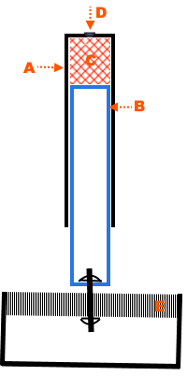

To start with a simple thought experiment. We have a metal tube sealed at one end ( A ). Then we slide a piece of foam ( C ) into the top of tube “A”. While a similar tube ( B ) also capped on one end slides into “A”. To slide the tube “B” in will be hard as there is air trapped between the two tubes. So you need to drill a small hole ( D ) in the top of tube “A” and slide the inner “B” up to the foam. You then fix the top of the tube “A” to a fixed surface and you attached the bottom of the inner tube “B” to the centre of a sprung surface ( E ). You then seal up the hole in the top “D”. Now this analogy isn't perfect but its close enough to use as a example.

If we beat our fists on the sprung surface, the kinetic energy will move from our fists, though the sprung surface and onto the bottom of the pipe, squeezing the air and the foam between the two end-caps. This will generate a small amount of heat. Another way of thinking about it would be by striking a anvil with a hammer. the kinetic energy of the moving hammer is transformed in to sound (Acoustic energy or Pressure waves) and heat (Thermal energy) in the mass of the Anvil. The two differences is that there are 3 different mechanisms, one is the compression of a gas and a foam the other a solid mass. However the result is still heating of said materials.

Now this is where the analogy breaks down a little. If we were to extract the converted heat energy and put it back into the sprung surface. We would need two things, one something to collect the heat, this could be located were the foam is, the second would be to transform that energy from the collection point into something the sprung surface could use to move.

Now if you think I am talking about some-sort of self oscillating big bounce machine,your kindly mistaken. More of a energy conservation system. Where in a event of any energy loss in the sprung surface, maybe possible a violent event. The foam and air can safely capture the energy and recycle it, as if it wasn’t there. You would have a event where our universe would be mathematical intangible.

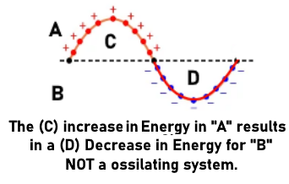

So we have our machine, can we apply it to our universe. We are missing two things the Foam and the Collection system, Now this is where I have to speculate. But I think a great contender for this would be what we refer to as dark energy / dark matter . I am lumping them together as in my system the difference between the two could just be ones warmer than the other.

The speculated collection system for this would be a black hole, But lets imagine it. You have a event, that's like dropping a stone into water. You have a wave moving though the Dark matter / Dark energy. Now if there's enough mass to start reactions such as Pair production and Annihilation. Then we can go towards more conventional physics, But with one change. Now matter is moving inside inside a structure. Which if anything works just as well. As there is a possibility to have matter clumping together, With the Dark matter / Dark energy flowing in between. Combine that with the matter going in the direction of the initial direction of the wave. From our point of view the universe would appear be expanding.

One point id quickly bring up is maybe the possibility of the Dark matter / Dark energy acting as a Bose Einstein condensate, where supercooled atoms begin to clump together and start to behave as a singular atom. It would be interesting to see this modelled on a computer, As it may be a alternative to inflation theory..

Now I will end it here as part 1. Any thoughts or opinions will be very much appreciated.

Kind regards.
Rick.

